
Lab: Interpreting and Matching
Displacement vs. Time Motion Graphs

Objectives:
- Create a Displacement vs. Time graph and match your graph with actual motion.
- Gain competence in the use of motion detector and related equipment.
- Understand the relationship between position vs. time, velocity and acceleration.

Materials:

TI-84 Calculator-Based Lab Unit (CBL-II)

Motion detector

Meter stick

Computer with LoggerPro software

Procedure:

Part I –
- Develop a position vs. time story that describes a body in motion incorporating at least the following four types of motion.
    - standing still
    - moving with constant velocity
    - moving with variable negative velocity
    - moving with variable positive velocity
- Illustrate the story on a position vs. time graph. Use a legend to cross reference sections of the graph with the corresponding sections of the story.
- Underneath the graph, write instructions for moving in front of the motion detector according to the graph you have drawn (see page 2 for example).

Part II – AT THE LAB STATION IN CLASS WITH A PARTNER
4. Measure out and mark meaningful locations on the floor and practice the motion needed to create the position vs. time graph.

- Now it’s time for you to match your physical motion to your group’s descriptive motion graph. You have 3 attempts to match it as best you can. Save a copy best graph your motion creates and reproduce this graph using LoggerPro.

Story:
- Bob is an angel and he’s been sent from Heaven to go on a special mission. Bob’s mission: buy ice cream. That’s right, God is hungry. So, Bob decides to fly down to Dairy Queen at 5 meters per second at a constant speed for 20 seconds.
- When he arrives at Dairy Queen, he stands in line for 2 seconds.
- He gets the ice cream, and preparing for take-off, he accelerates in the positive direction towards heaven at 4 meters per second for 14 seconds.
- As he is flying, he decides to take a bite of the ice cream. Since he is no longer focusing on flying, he falls to earth at a negative velocity at 3 meters per second for 4 seconds.
- Not noticing the nearby plane, he gets hit, immediately knocking him unconscious.
- He arrives in heaven and gives God the empty ice cream container. Needless to say, Bob is not going to be sent on a mission any time soon.
Table for Logger Graph:

Time (sec):
Position (m)
2.4 0.591968
2.45 0.585582
2.5 0.579473
2.55 0.574475
2.6 0.571143
2.65 0.5692
2.7 0.568922
2.75 0.568645
2.8 0.566979
2.85 0.567534
2.9 0.571976
2.95 0.576141
3 0.582805
3.05 0.590302
3.1 0.598076
3.15 0.606128
3.2 0.611959
3.25 0.620567
3.3 0.631118
3.35 0.641946
3.4 0.651942
3.45 0.662215
3.5 0.669712
3.55 0.680819
3.6 0.695257
3.65 0.708029
3.7 0.717192
3.75 0.729964
3.8 0.743847
3.85 0.759396
3.9 0.777444
3.95 0.794381
4 0.814372
4.05 0.827422
4.1 0.841583
4.15 0.8538
4.2 0.86796
4.25 0.878789
4.3 0.886563
4.35 0.89406
4.4 0.899613
4.45 0.904889
4.5 0.912663
4.55 0.914329
4.6 0.916273
4.65 0.91544
4.7 0.912108
4.75 0.91072

4.8 0.902945
4.85 0.895726
4.9 0.883232
4.95 0.835197
0 0.906
0.05 0.905444
0.1 0.905722
0.15 0.905722
0.2 0.905722
0.25 0.904889
0.3 0.904056
0.35 0.901835
0.4 0.899613
0.45 0.897114
0.5 0.893783
0.55 0.889895
0.6 0.88462
0.65 0.879067
0.7 0.873236
0.75 0.866572
0.8 0.859908
0.85 0.853244
0.9 0.847414
0.95 0.841027
1 0.834641
1.05 0.827145
1.1 0.819648
1.15 0.812429
1.2 0.804099
1.25 0.795769
1.3 0.787162
1.35 0.777721
1.4 0.768559
1.45 0.758841
1.5 0.749123
1.55 0.739127
1.6 0.729686
1.65 0.719968
1.7 0.71025
1.75 0.701365
1.8 0.692203
1.85 0.683873
1.9 0.675265
1.95 0.666936
2 0.657773
2.05 0.649165
2.1 0.640836
2.15 0.630562
2.2 0.621955
2.25 0.613625
2.3 0.606684
2.35 0.599465

Logger Graph:
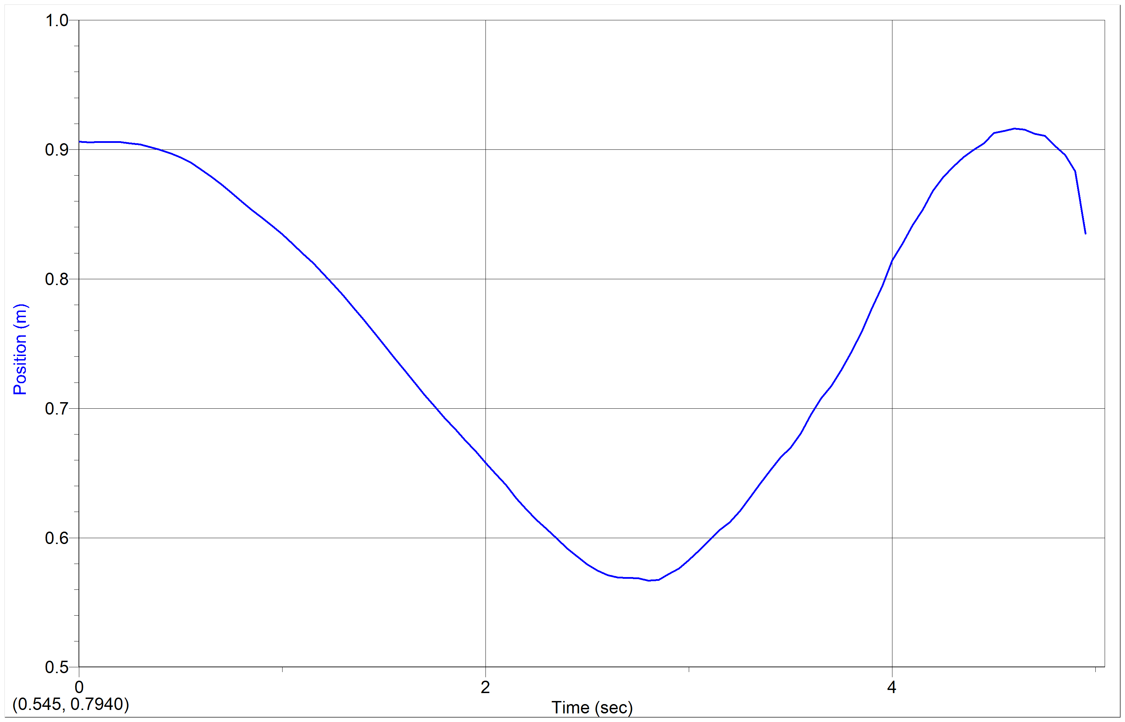
Directions for Motion Detector:
1: Set motion detector to collect data every 0.5 seconds for 5 seconds. Each second will represent 8 seconds in the story.
2: Stand a few feet away from the motion detector.
3: Upon starting the motion detector, immediately move forward at a constant speed toward the motion detector for 2.5 seconds.
4: Pause where you are for 0.25 seconds.
5: Move backward, gradually increasing speed for 1.75 seconds
6: Quickly move forward without stopping, moving for 0.5 seconds.
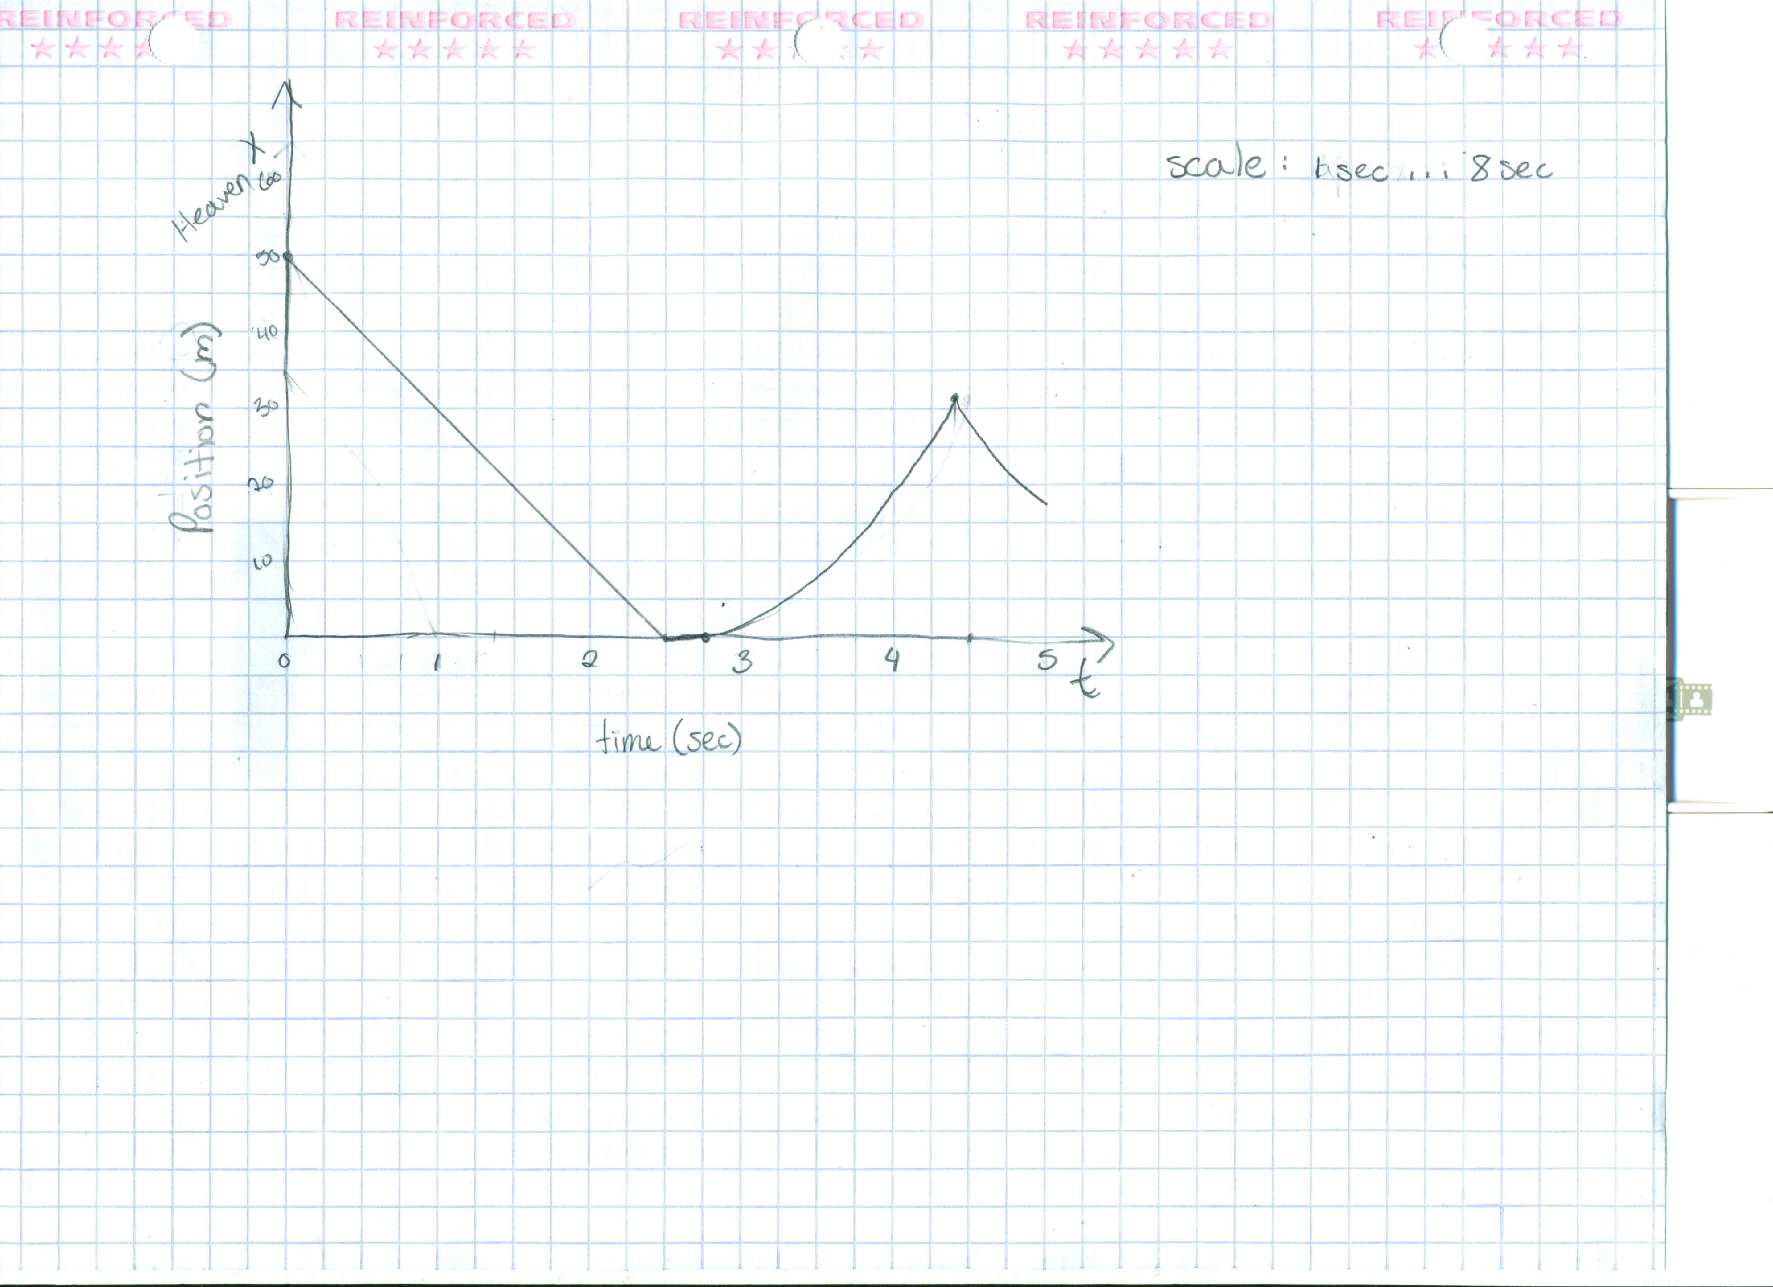
Made-up graph:
Data Analysis: Discuss differences between the descriptive graph and the graph generated by the motion detector. What are the reasons for the differences?
**The descriptive graph shows the perfect instance of our story while the motion detector graph only shows our attempted to replicate the mentioned motion. This is because mathematically replicating the situation on paper can create exactly the instance that we’re looking for while the motion detector graph holds human error in replicated motion in a shorter amount of time.

Conclusion: Develop a conclusion that addresses the objectives of the lab.

**This lab allowed the users to use their knowledge of physics to recreate their predicted graph using real (or fake) examples and physically “going through the motions” of the graph in front of a motion detector. This shows the difficulty in recreating motion and also the necessary movement required to match a graph in both position, time, and velocity.

